Job Recruitment Based News Portal

***Introduction:***

A news portal that connects employers and job seekers where job seekers can identify and apply for their desired jobs and employers are the source of the resources is called a job recruitment news portal.



Nowadays a job portal plays a significant role in every hiring process. It’s main objectives are:

$•$ Gives a right career choosing guidance for job seekers.

$•$ Easy and time saving for recruiters and hiring managers to verify resume online.

$•$ Very affordable and cost-effective way for advertising your company.

$•$ Opens so many options for the job seekers.

***Feature:***

•Job posting

•Individual Categories

- Medical Jobs

- Technology Jobs

- Bank/Finance Jobs

- Other Jobs

•Effective job description

•Daily Updates

•Free advertisement for companies

•Latest job news highlighting

***Language and tool used:***

•Html • MySQL

•Css • Javascript

•Php

***Operations:***

There will be 2 types of operations:

1. We gather recruitment resources from various sites and post it to our portal and promote/ advertise it.

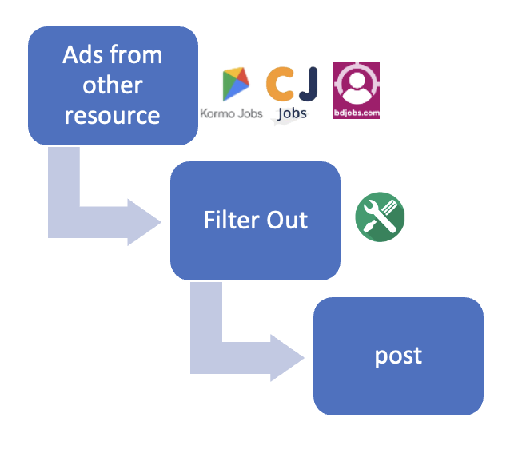

1. Companies can directly contact us (Contact Information are given in ‘contact us’ section) and post their hiring advertisement with effective requirements.

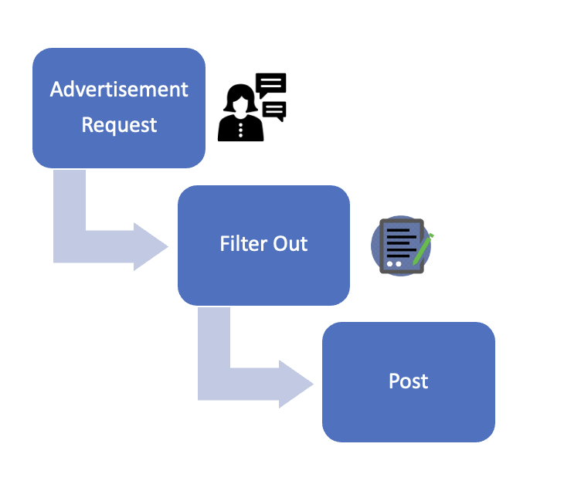

***Revenue Model:***

AdSense.

Paid advertisement.

***Limitation:***

Internet needed to get access.

Can be attacked by virus.

***Conclusion:***

Particularly for college graduates who are more likely to look for work online, online job ads can be a useful tool for matching real people with real opportunities in real time.